**INTRODUCTION TO AI & AI LADDER**

**The AI Ladder:** Data is the Fuel for AI

**INFUSE:** Operationalize AI throughout the business.

**ANALYZE:** Build and scale with trust and transparency.

**ORGANIZE:** Create a business-ready analytics Foundation.

**COLLECT:** Make data simple and accessible.

**TOPICS:**

I) INTRODUCTION TO THE AI LADDER AND FUNDAMENTALS OF AI.

II) NO AI WITHOUT IA

III) FIRST STEP IN LADDER: COLLECT DATA

IV) SECOND STEP IN LADDER: ORGANIZE DATA

V) THIRD STEP IN LADDER: ANALYSE DATA

VI) FOURTH STEP IN THE LADDER: INFUSE DATA

VII) END REVIEW AND EVALUATION.

**1) INTRODUCTION TO AI:**

**Accelerate your journey to AI!**

AI is the greatest opportunity and challenge of our time. It is most definitively the defining transformation technology of this era. Industries worldwide are ready and eager to adopt an AI solution. In fact, in 2019, 40 percent of digital transformation initiatives used AI, and significantly more will do so in 2020 and beyond.

As companies continue to harness the potential of AI, they need to use data from diverse sources, support best-in-class tools and frameworks, and run models across a variety of environments. However, 81 percent of business leaders do not understand the data and infrastructure required for AI. Even if they did, 80 percent of data is either inaccessible, untrusted, or unanalyzed - stored in multiple disparate systems and/or complex data types.

|  |
| --- |
| *“No amount of AI algorithmic sophistication will overcome a lack of data [architecture] … bad data is simply paralyzing.”* |
| – MIT Sloan |
|  |

Simply put… *there is no AI without information architecture (IA)*.

With a unified, prescriptive IA, you can accelerate your journey to AI to unlock the value of your data for an AI and hybrid, multicloud world.

This course will provide you with the strategic tools you will need to:

Understand the strategic advantages of AI

Develop a strategic vision for AI in your enterprise

Communicate your strategic vision to the AI experts in your enterprise

**Drivers of AI:**

**AI is the new electricity:**

AI is one of the greatest challenges and opportunities of our time. It is poised to change the way people work, to change how enterprises operate, and to transform entire industries. AI initiatives offer cost savings while helping organizations predict and shape future outcomes. They do this through automating routine tasks and augmenting human intelligence to allow us to work on more significant responsibilities.

But AI is not magic, instead it is a series of software and data engineering techniques for making sense out of a vast amount of data. *In order for AI software to learn the information it needs to know to help humans analyze information and make decisions, it must be trained using the data that it needs, making data the foundation and fuel for AI.*

This produces a unique business challenge for leaders. While most business leaders list improving the use of data as a top priority, only a small percent of them are actually getting what they need from their data.

**Artificial Intelligence:** A Program that can sense, reason, act and adapt.

**Machine Larning:** Algorithms whose performance improves as they are exposed to more data over time.

**Deep Learning:** A Subset of machine learning in which multi-layered neural networks learn from vase amounts of data.

**FUNDAMENTALS OF AI:**

**Raw Data 🡪 Processed Data 🡪 Algorithms 🡪 Predict & Explain 🡪 Results Interpretation based on Business context.**

The results are probabilistic **(x%)**, not the deterministic **(If X = Y, Then Z)**. A Prediction will not say it is outcome, it will only give probabilistic outcome which can be wrong.

Can I use a set of Sales figures and Sales Incentive Plans and Sales persons profile to predict the future?  
 Raw Data are 🡪 Databases 🡪 Cleaned Data 🡪 Trained Machine Learning Model 🡪 Query trained ML Model.

Machine Learning contains Predict, Explain, Algorithm, Data. Collectively this ability is called as Machine Learning.

Algorithms of Machine Learning:

1. Supervised Learning
2. Unsupervised Learning
3. Deep Learning
4. Reinforcement Learning

**Supervised Learning:**

It is most commonly used algorithm for predictions. Gather pre-defined data, selecting and labelling it and use them for its training by feeding them to its algorithms.

New Input 🡪 Trained Algorithm 🡪 Predicted Y

Examples: Predicting a prospect ability to repay a loan, predicting fraudulent insurance claims, predicting machinery points of failure.

**Unsupervised Learning:**

Gathers Un-organized data and groups and separates them as and feed them to algorithm. Anomaly (Frauds) detection and grouping data with a natural affinity.

New input 🡪 Trained Algorithm 🡪 Group 1, 2 & 3

Examples: Customer Segmentation and Image Classification.

**Deep Learning:**

They are helpful in places of huge amounts of data and unstructured data. They are based on family of algorithms called neural networks that aim to emulate how the brain and neuron connection work. They are black boxes and their predictions are hard to explain.

Examples: Predictions in gene ontology and gene-function relationships, health predictions based on data collected from wearables.

**Reinforcement Learning Algorithm:**

A Reinforcement learning algorithm is used in scenarios where a mechanism of reward for success and penalization for failure leads to optimal outcomes. Used commonly where large amounts of labelled data with correct input output pairs are explicitly presented.

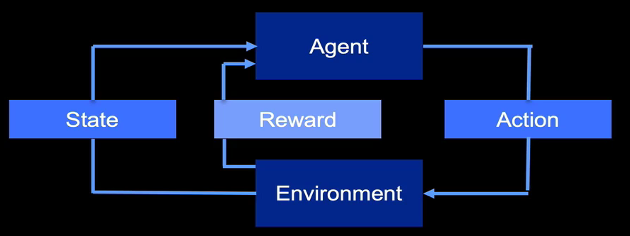

Examples:

1. Training a robot to learn specific policies.
2. Bidding in advertising
3. Games.

**AI Specialization:**

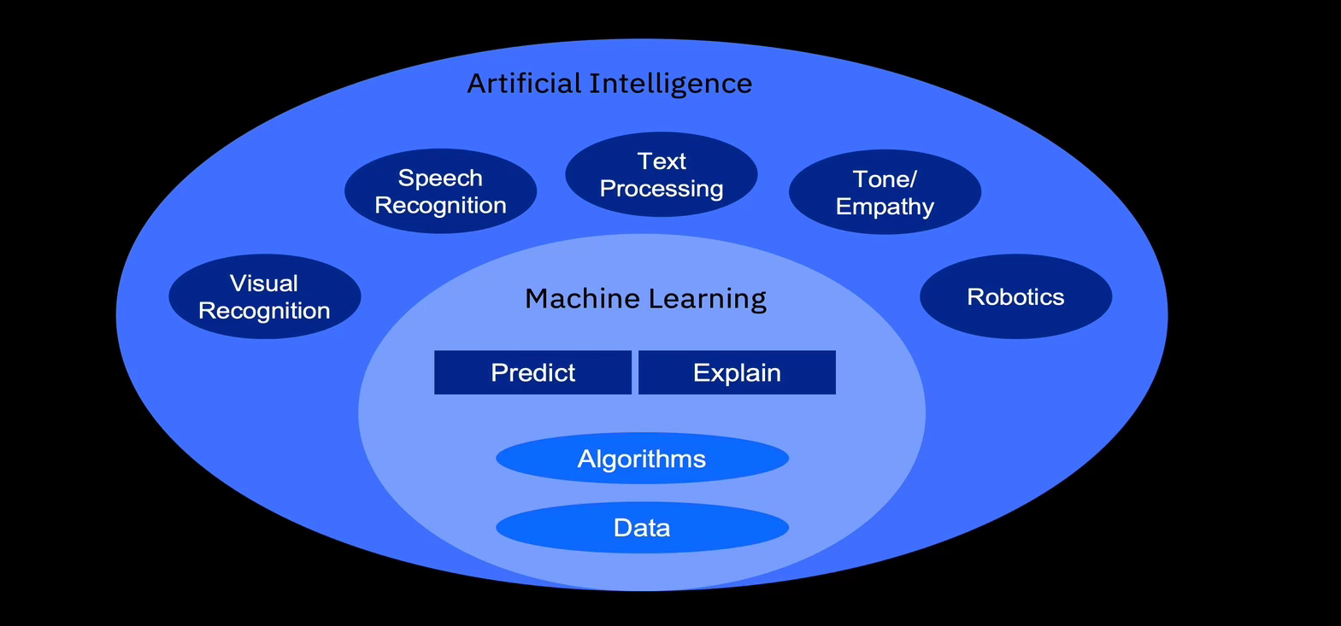

**Visual Recognition:**

Any AI system that processed visual information usually relies on visual recognition algorithms, these algorithms are capable of identifying specific objects or categorizing images.

**Speech Recognition:**

It is an ability of a machine or program to identify the words or phrases in spoken language and convert them to a machine-readable format. Natural language processing (NLP) is used in speech recognition algorithms.

**Text Processing:**

Text processing algorithms can understand complex concepts and identify patterns and trends across million of articles to provide valuable information. Natural Language processing (NLP) is used in text processing algorithm.

**Tone/Empathy:**

They are the algorithms aim to read and respond to emotion to improve communications between AI and humans and to build a better AI solution incorporating emotions as input.

**Robotics:**

Robotics deals with design, construction, operation, and use of robots, as well as computer systems for their control, sensory, feedback, and information processing.

**AI is about three things:**

1. **Prediction,**
2. **Automation and**
3. **Optimization.**

**Three Key Drivers:**

1. **The AI Ladder,**
2. **Modernize your data environment**
3. **Open Source.**

**II) NO AI WITH IA:**

**INFUSE 🡪 Operationalize AI throughout the business**

**ANALYSE 🡪 Build and scale AI with trust and transparency**

**ORGANIZE 🡪 Create a business-ready analytics Foundation**

**COLLECT 🡪 Make data simple and accessible**

**MODERNIZE 🡪 Make your data ready for an AI and multi cloud world**

## Modernizing your information architecture:

## In order to prepare your data for AI and hybrid cloud, and to make the journey to AI possible, it is important for your organization to build a reliable information architecture (IA) that is efficient and agile.

The architecture that your organization creates will be the most successful if it is an elastic and extensible multi-cloud infrastructure that unifies key capabilities around:

* collecting
* organizing
* analyzing, and
* infusing data

*Modernize* means building an information architecture for AI that provides choices and flexibility across your business. As you modernize your data estates for an AI and multi-cloud world, you will find that there is less work required to expand and infuse AI throughout your business processes.

### **AI is not magic**

AI is not magic. It’s computer science. There is no magical wand that exists to fix enterprise inefficiencies, and access to the technology is not enough. AI adoption necessitates a thoughtful approach with an efficient, well thought-out information architecture.

The vast majority of AI failures are due to the lack of data preparation and organization, not the AI models or use cases. There are three major challenges organizations must overcome to truly transform into an AI-first company:

* Data: Either too much data, not enough data or bad, irrelevant data.
* Skills: AI skills are new, rare, and in high demand.
* Trust: The decisions made with AI systems must be accountable, traceable

This course will focus primarily on the first challenge listed above, *data*.

### **There is no AI without IA**

There is no AI without Information Architecture (IA). IA is the practice of structuring data for a purpose. For the purpose of AI, IA’s purpose is to create a unified, organized data collection that can drive analysis on a multi-cloud platform.

Creating the appropriate IA allows your organization to have the ability to simplify and automate the process of transforming data into insights using machine learning models, as well as implementing other AI tools and capabilities.

**Collect Data:**

**Three keyways for collect:**

1. **There’s no AI without IA,**
2. **Clients need to be able to access all of their data,**
3. **Access to insights across the organization.**

**Collect: Making data simple and accessible:**

**After you've modernized your information architecture, it is time to make your data simple and accessible.**

What does "simple and accessible" mean? To understand this, consider what it looks like when data are not simple and accessible:

* Data locked away in systems-of-record, inaccessible to most
* Data silos isolated by inflexible platforms that cannot interface with other platforms
* Siloed business functions and data types

Siloed data means data that cannot be used for gaining analytical insights. As your business grows and evolves, these basic challenges tend to get worse. In the end, no amount of AI will help transform an organization with siloed data because*the insights gained by AI are only as good as the data used to derive those insights*.

**For organizations that want to adopt AI solutions, access to data is critical to create smarter, transparent, and trusted AI applications.**

For example, consider a retail company that currently only has access to their historical, transactional data. That means their AI models are being trained using only one data source.

If instead this company combined their structured transactional data with unstructured data from sources like social-media data or real-time clickstreams, they would be able to build AI models that tell what their customers bought last week, how they feel about their purchases, and what they’re shopping for this very second, giving the retail company a multi-dimensional view of their customers.

An appropriate data management strategy is critical

An appropriate hybrid data-management strategy will allow companies to successfully implement AI. To implement this strategy, focus on how your employees will have:

* Access to all data regardless of source or type
* Flexibility to support changing workloads and consumption cases
* Access to intelligent analytics, such as machine learning, that can run at the source of data
* Access to insights across the business, its functions, and to all users for better decision making

**Collect Steps for AI Ladder:  
1) Understanding business challenges faced by different units at different times.**

**2) Using all the available data.**

**3) Use AI powered tool to manage data.**

**Organizing your data:**

**When organizations are able to collect their data and make it accessible throughout their business, the next step is to make sure it’s organized in a trusted, business-ready foundation.**

Data is the bread and butter of AI and the quality of that data directly affects the results of the organization's AI. Organizations need their data to be *organized*, *cataloged*, and *governed* to ensure that only the people who should be able to access it have the appropriate access rights.

To understand why it’s important to organize and catalog data, an analogy of a grocery store is useful. When you go to a grocery store, all of the products are sorted by aisle and each aisle has a list of categories hanging overhead. Grocery stores are useful because they are organized and provide an overhead catalog to help shoppers quickly find what they need. If a grocery store was simply a room filled with thousands of products, it would have less value to its shoppers. Shoppers would waste time looking for products they would not be organized in a logical way.

*Data is the same*. Organizations need to have a catalog of their data that provides information, including the data’s source, who owns it, and how the metadata is mapped to its business context. Organizing data properly helps companies:

* Profile, cleanse, and catalog all types of data
* Manage data with built-in protection and compliance
* Enable policy-driven visibility, detection, and reporting
* Manage data at all stages of the information lifecycle, from creation to deletion

**Organize Data:**

**Three keyways for Organize Data:**

1. **Data is trust-worthy, complete and consistence,**
2. **Data catalog and governance**
3. **Data compliance**

**What does Organize mean?**

At a high level: Making sure the data is ready for use by business users, specifically refers to:

1. Addressing data quality,
2. Organizing and cataloging data
3. Governing of data.

**What are Data catalogs?**

The catalogs include data toplogy and essential business terms for structured data. They helps to enforce the defined topology by:

1. Using policies and rules.
2. Establishing Lineage
3. Adding unstructured data.

**Analyzing your data:**

**Once organizations have been able to collect their data and organize it in a trusted, unified view, they can now tap into that data to build and scale AI models across their business.**

In order to build AI models from the ground up and scale them across the business, organizations need capabilities covering the full AI lifecycle. This includes:

* **Build**: At this phase in the AI lifecycle, it is critical to ensure companies use the right algorithms to build their models for making predictions.
* **Run**: Put custom models into production, in an application or business process. Once a model is built and running, the question becomes: how can it be scaled with trust and transparency? This is where management plays a crucial role.
* **Manage**: By having the management in place, organizations can track who changed the model, when the model was deployed, and the lineage on the model. By tracking all these items, organizations can ensure their models are not biased, and that they’re explainable and transparent.

In today’s world of regulations, General Data Protection Regulation (GDPR), and data privacy laws, the way organizations engage with AI is under intense scrutiny. Organizations need to manage their AI across the entire AI lifecycle in order to explain either to a consumer, or another business, how their systems came to a decision and why.

For example, a bank needs to be able to tell a consumer what the factors were behind their loan being denied, and what they would need to do to change that decision.

Ultimately what is needed is a set of modular components, flexible environments, and tools that make analyzing data and building AI models easier and more accessible. These tools should be based on open source frameworks which support a multicloud environment, and a full end-to-end automated lifecycle which enables trust and transparency.

For example, fraud activities have only continued to increase at a rapid pace over the years. Fraud is difficult to predict. That’s because the data is overwhelming and information is siloed, making it difficult to get a "360 degree" view. This leads to false positives or missed alerts, costing companies hundreds of millions of dollars. In this context, data analysis is based upon predictive insights, real-time analysis, sophisticated modeling techniques and automation technologies, all in a governed and secure environment.

**What is analyse?**

1. **Build: using right algorithm.**
2. **Run: Putting it into production.**
3. **Manage: trustworthy? Transparent? Scalable?**

**Three keyways for analysing**

1. **Being able to build & collaborate**
2. **Scale across enterprises**
3. **Trust & Transparency**

**Analysing:**

**After data has been collected & organized, it is ready to be used. It can be used to build and scale the AI models across all the enterprises, and gain insights from all of the data.**

**Managing the new model in production:**

**Over the conditions change and the model may have to be restrained with new, updated data sources. Also, the model must be monitored for any unintended biases in the predictions it makes.**

**Infuse AI:**

**The infuse step of the ladder focuses on applying AI throughout the business.**

AI solutions can be leveraged across your business within various processes from payroll to customer care to marketing benefiting from its ability to draw on predictions, automation, and optimization. Infusing AI helps you advance your business agenda.

Most organizations are still in the early days of determining how and where to use AI, but there is tremendous optimism.

According to Gartner:

* 37 percent of companies are adopting AI in some form or fashion.
* 52 percent of telecommunications firms, for example, are already deploying chatbots bolstered by AI to improve customer experiences and services.
* 49 percent of enterprises are already changing their business models to integrate and adopt new technological solutions throughout their internal processes and supply chains.

IBM (building on projects with thousands of organizations) has observed that organizations are looking to:

* Speed time to value with pre-built AI apps for common use case (for example, customer service and financial planning)
* Automate knowledge work and business processes
* Employ AI-assisted business intelligence and data visualization
* Automate planning, budgeting, and forecasting analytics
* Customize with industry vertical AI-driven frameworks Innovate with new business models intelligently powered by AI

#### **Examples**

* **Marketing**: Companies can predict shopping trends and optimize their marketing strategies and product placement or deliver ads that are engaging, relevant, and personal.
* **Supply chain**: Companies have visibility and insights to make informed decisions and mitigate disruptions before they impact their ability to deliver business results.
* **Customer care**: Enterprises are looking to transform their customer experience, deliver fast resolution and provide round-the-clock accessibility. Increasingly, they are turning to conversational solutions, often referred to as chatbots, to tackle the most common interactions, questions, and tasks.
* **Human resources**: Companies can predict with accuracy which employees are at risk of attrition. AI also can be used to help employees identify new skills training, education, job promotions, and raises.
* **Knowledge workers** like procurement professionals and lawyers can craft and manage contracts and legal documents with less effort and more accuracy, saving both time and money.
* **Insurance**: With AI, the claims approval process for insurance carriers is more consistent and automated, can more accurately predict risk assessments, and ensure fair outcomes for customers. This allows their employees to focus on higher-value tasks while still allowing their employees to explain how those AI decisions were made.
* **Enterprise Financial Planning**:  By investing in an AI-powered financial analytics solution, organizations can develop next-generation CFOs who can apply predictive analytics and unlock the value previously hidden in their data. This allows organizations to break free of manual, error-prone work.

#### **Real-life example of Infuse AI**

A global, independent energy company has been a world leader in oil and gas exploration for over 50 years.  What is their key to success?

They hire and develop some of the world’s best engineering experts. This approach has helped the company to create some of the largest structures on earth, in some of the most remotest seas, and to safely transport the energy it extracts around the globe.

This company knew that it had to harness the institutional knowledge of its best engineers.  By harnessing the power of AI, the company was able to extract meaningful insights from 30 years of complex engineering data and reports, and then make this knowledge easily available to employees across the company. This helped the organization answer tough questions faster to enable fact-driven decision making on complex projects.

Read more about this fascinating project at this link: <https://www.ibm.com/case-studies/woodside-energy-watson-cognitive>

**Infuse**

* 1. **Predict and shape future outcomes.**
  2. **Optimize people to do higher value work.**
  3. **Automate decisions, processed and experiences.**
  4. **Re-image new business models.**

**Keyways:**

1. **Putting AI to work**
2. **Automate and Optimization**
3. **Unlock New value.**

**Summary/ Review:**

## Introduction to AI and the AI Ladder: Summary/Review

#### **AI is the new electricity**

AI is one of the greatest challenges and opportunities of our time. It is poised to change the way people work, to change how enterprises operate, and to transform entire industries. AI initiatives offer cost savings while helping organizations predict and shape future outcomes. They do this through automating routine tasks and augmenting human intelligence to allow us to work on more significant responsibilities.

But AI is not magic, instead it is a series of software and data engineering techniques for making sense out of a vast amount of data. In order for AI software to learn the information it needs to know to help humans analyze information and make decisions, it must be trained using the data that it needs, making data the foundation and fuel for AI.

#### **Fundamentals of AI**

The following key terms and definitions are important to understand the information in this course:

1. **Artificial intelligence** is the field of building computer programs to perform tasks that typically require human intelligence including visual recognition, speech recognition, language processing and decision making.
2. **Machine learning** is the field of building models to classify and make predictions from data.
3. **Deep learning** is the field of building models to unsupervised models from unclassified data to make decisions through an artificial neural network.

#### **A brief explanation of AI**

At the enterprise level, AI is a tool to improving human decision making, at speed and scale, and has the potential to augment the work of every employee. AI accomplishes this by improving predictions, automation, and optimization of time and resources to drive better decisions and improve business outcomes.

1. **Predictions** - Organizations want to be able to forecast what’s going to happen in their business, at both the macro and micro level.
2. **Automation** - By automating critical, yet time-consuming, business processes that are often done manually, employees are free to focus on higher-value, more creative work. According to Gartner, AI augmentation will recover 6.2 billion hours of worker productivity in 2021.
3. **Optimization** - Whether this means optimizing routing and logistics, marketing spending, or the configuration of the client's cloud installation, AI is a tool for improving human decision-making at speed and scale and has the potential to augment the work of every employee.

#### **The AI Opportunity**

The influence of AI will become larger as AI becomes increasingly embedded in other applications and workflows, including analytics tools. According to the IDC Worldwide Spending Guide on Cognitive and AI Systems, AI software spending will grow 43 percent to reach USD 31 billion by 2022, yet only 20 percent of analytic insights will deliver business outcomes. Data science and machine learning surveys often indicate that less than 50 percent of data science and machine learning analytic assets are deployed in production.

Companies will have to be able to connect their data to AI in order to deliver smarter business outcomes. To successfully bring the power of AI into a business, companies will have to rethink how to build solutions that utilize AI technology.

#### **How will AI impact organizations?**

Data is the foundation and fuel for businesses to drive smarter decisions, particularly as they embark upon digital transformations. The problem is that while 90 percent of business leaders list improving the use of data as a top priority, only 15 percent of them are actually getting what they need from their data (Source: IBM Data 2020; The State of Big Data, 2017). As a result, the majority of businesses have a plan to build a system of insights to become data driven and have declared the journey to AI as a strategic priority.

However, organizations still struggle to understand and execute on the steps they need to take to advance their AI agenda.

#### **Modernize your Information Architecture (IA)**

*There is no AI without IA*

“Modernize,” in this context, means building an information architecture for AI that provides choice and flexibility across the organization. To meet today’s demands and to stay competitive tomorrow, organizations need an efficient, agile architecture for their data that they can reliably build on. Enter hybrid, multicloud platforms.

Hybrid, multicloud platforms are the future of data architecture. A hybrid, multicloud platform allows organizations to take advantage of their data and applications across any cloud (public, private, on- premises) via containers. As enterprises modernize for an AI and multicloud world, they will find there is less “assembly required” in expanding the impact of AI across the organization.

#### **The AI Ladder**

The challenge to begin the journey to build AI solutions can seem daunting, but there is a prescriptive approach to accelerate the journey to AI, called the AI ladder. The AI Ladder will help your business overcome challenges and drive digital transformation in your business, no matter where you are on your journey. The AI ladder helps you evaluate your organization’s readiness for AI and provides you with a series of steps on how to reach your AI goals. It’s important to note that readying an organization for AI isn’t a linear journey. Knowing the steps of the ladder helps you identify where your organization is strong and where your gaps are.

It includes the following steps:

**Step 1: Collect** - Make data simple and accessible. Collect data, regardless of where it lives, enabling flexibility with constantly changing data sources.

**Step 2: Organize** - Create a business-ready analytics foundation. Organize your data into a trusted, business-ready foundation with governance, protection, and compliance built in.

**Step 3: Analyze** – Build and scale AI with trust and transparency.  Analyze your organization’s data by using AI models that empower your team to gain new insights, make smart decisions, and scale with trust and transparency.

**Step 4: Infuse** – Operationalize AI throughout the business.  Leverage AI throughout your business, across multiple departments and within various processes, by putting AI to work to draw on predictions, automation, and optimization.